**MICROSERVICES**

**Hands-On 1: Creating Microservices for account and loan**

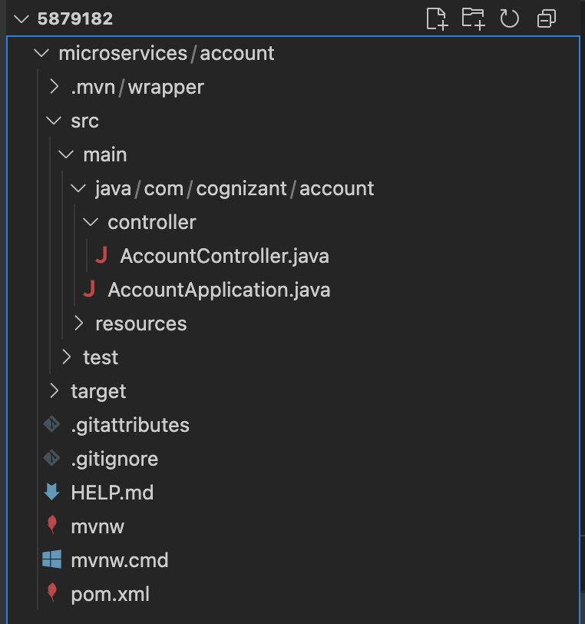

**AccountController.java:**

package com.cognizant.account.controller;

import java.util.Map;

import org.springframework.web.bind.annotation.GetMapping;

import org.springframework.web.bind.annotation.PathVariable;

import org.springframework.web.bind.annotation.RequestMapping;

import org.springframework.web.bind.annotation.RestController;

@RestController

@RequestMapping("/accounts")

public class AccountController {

@GetMapping("/{number}")

public Map<String, Object> getAccount(@PathVariable String number) {

return Map.of(

"number", number,

"type", "savings",

"balance", 234343

);

}

}

Output:

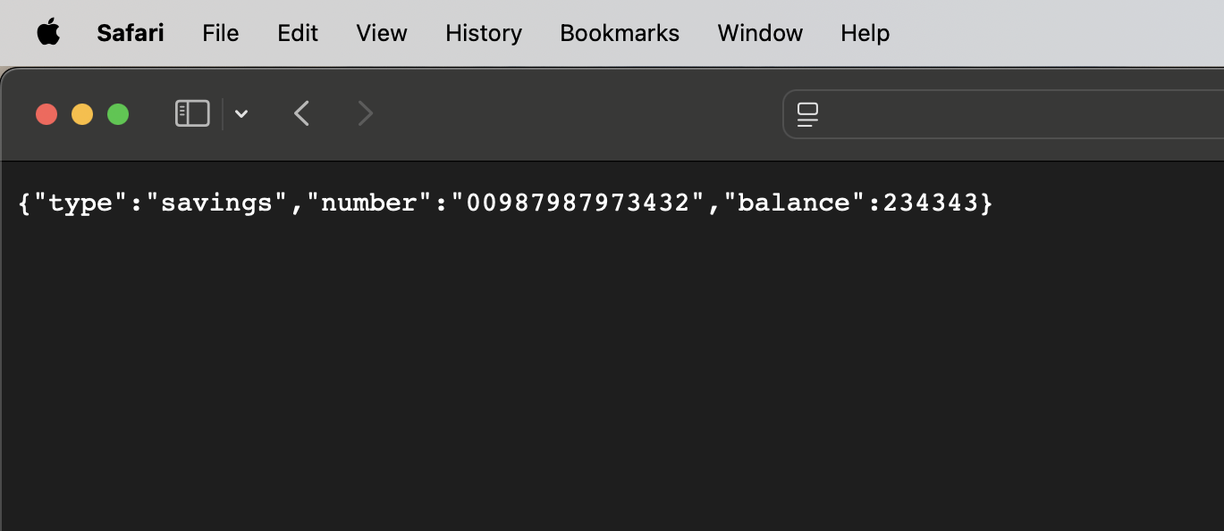

**Hands-On 2: Create Eureka Discovery Server and register microservices**

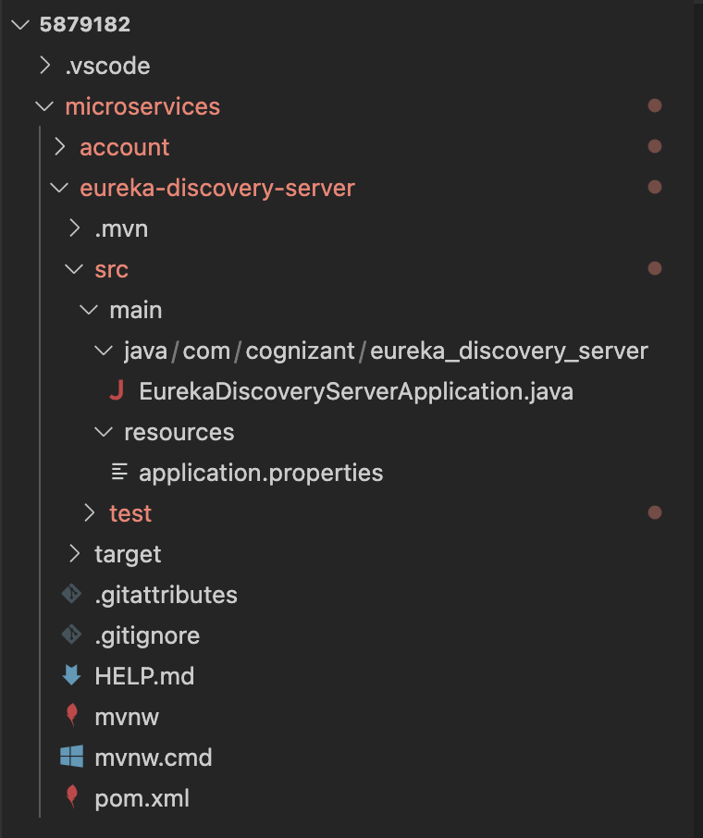

EurekaDiscoveryServerApplication.java:

package com.cognizant.eureka_discovery_server;

import org.springframework.boot.SpringApplication;

import org.springframework.boot.autoconfigure.SpringBootApplication;

import org.springframework.cloud.netflix.eureka.server.EnableEurekaServer;

@SpringBootApplication

@EnableEurekaServer

public class EurekaDiscoveryServerApplication {

public static void main(String[] args) {

SpringApplication.run(EurekaDiscoveryServerApplication.class, args);

}

}

Application.properties:

spring.application.name=eureka-discovery-server

server.port=8761

eureka.client.register-with-eureka=false

eureka.client.fetch-registry=false

Output:

